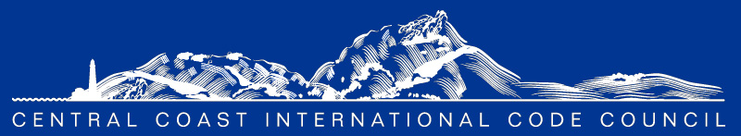

ICC Preferred Provider
AGENDA

Monthly CCC ICC Chapter Meeting Location: Microsoft Teams Link Below

Virtual - Via Online Meeting:
June 1, 2023, at 8:00 am Microsoft Teams: 1-323-457-5183
Conference ID: 758 197 302#

8:00 am- Self-Introductions – Turn on those webcams we love to see your smiles.

- Program:

- Please welcome our new ICC Regional Manager for Government Relations, Karyn Beebe!
- Electronic plan review kick-off discussion
- What capacity are you performing digital plan review?
- What software are you currently using for electronic reviews?
- What challenges are you encountering?
- What would make things easier for you and your team?
- Looking to gather feedback and share tips and tricks to better serve your needs

- Approval of the minutes

- Approval of minutes from May 4, 2023 (attached)

- Announcements & Communication

- A huge thank you to our sponsors, CSG Consultants, Bureau Veritas, 4LEAF, and JAS Pacific for a great mixer event between the Central Coast AIA and ICC Chapter members on 5/22!
- Please check our website for all updates, communications, local job postings, etc.: https://centralcoasticc.com/
- Visit and follow our LinkedIn page - https://www.linkedin.com/company/central-coast-icc/
- CEC update from Amie Brousseau
- 3C-REN updates from John and/or Jordan - https://www.3c-ren.org/
- ICC update from Karyn - https://www.iccsafe.org/advocacy/gr-monthly-update/
- AIA Update from Greg Wynn - https://aiacentralcoast.org/
- CALBO Update from Ian Livingston

- New Business

  - 2022 Energy Code training series from 3C-Ren – joint effort from CCCICC and Ventura Chapter
  - Safety Fest this weekend in Paso Robles - https://pasosafe.com/event-overview
  - Code discussion topics: Open forum, roundtable
  - What additional trainings would you be interested in? Let us know and we’ll get on it!
  - Local job opportunities: Send us your job postings and we’ll post them on our website and LinkedIn page.
  - Please share your interesting topics, important events, unique projects, and new industry trends for us to post on our Chapter LinkedIn page.

- Unfinished Business

  - Don’t forget to renew your memberships! If you have questions regarding your membership status, please reach out to Mackenzie. You can also visit https://centralcoasticc.com/howtojoin/
  - CCCICC and AIA collaboration – Working on affiliate membership MOU with AIA

- Officers Reports

- President: Mark Sadowski
- Vice President: Dena Paschke
- Treasurer: Jesse Barron
- Secretary: Mackenzie Ramsey
- Past President: Rafael Cornejo

- Committee Reports

- Education Committee Chair: Mark Sadowski
- Scholarship Committee Chair: Sylvia Aldana
- Web Site Committee Chair: Mackenzie Ramsey
- Membership & Outreach Chair: Joe Chao
- Social Committee Chair: Bill Fitzpatrick
- Code Change Committee Roy Harthorn

COMMITTEES: The committees can only do what we as a group collectively help them do!

If you have an interest in volunteering to support the Chapter in any capacity, please let us know what interests you have, and we can assign a function that best suits your strengths.

Code Change Committee: Roy Harthorn
Education: Mark Sadowski
Website: Mackenzie Ramsey
Membership & Outreach: Joe Chao
Scholarship: Sylvia Aldana; Brian Cowen; Elizabeth Szwabowski; Bryan Spain
Social: Bill Fitzpatrick

- Adjournment – We truly appreciate you taking the time to join us today! Your continued investment and support in this Chapter is an essential part of what keeps us connected and thriving together!

