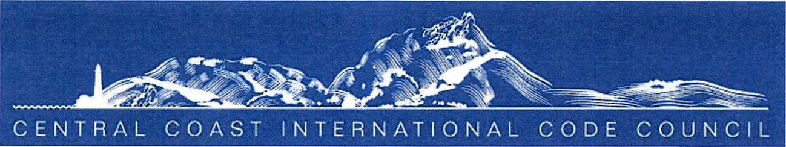

CENTRAL COAST INTERNATIONAL CODE COUNCIL’S FRED H. SCHOTT MEMORIAL SCHOLARSHIP PROGRAM
Student - Instructions
(Application Deadline: Friday, April 19th, 2024)

Up to $3,000 “No Essay” Central Coast International Code Council (CCCICC) Scholarship
Program

NEXT DEADLINE: Friday April 19, 2024 at 11:59 p.m. PST

Winner to be notified by email and awarded the scholarship at the ICC Central Coast Meeting on May 2nd 2024. Be sure to apply!

You could be the next recipient! How it works: One Junior college student will receive $1,000.00 (each) and two Cal Poly student $3,000.00 (each) will be awarded the scholarships. “No Essay” Central Coast International Code Council Scholarship Program is open to all qualifying students that have applied to Cuesta or Alan Hancock Community College and California Polytechnic State University San Luis Obispo. Three finalists in each category will be selected by the Scholarship Committee and will be recommended for consideration by the entire Chapter to vote for the finalist and winner of scholarship. The Scholarship Committee Chair will contact the winner and the winners name will also be announced on our Chapter webpage.

Who can apply? High school seniors, adults looking to head back to school, current college students and anyone else looking to attend college or graduate school this year. If interested, please go to http://centraIcoasticc.com/ to download and complete the Student Application Form. Provide proof of enrollment shall be required. Please be sure to submit the form prior to the Application Deadline to be considered. Please only submit one entry per person per year, but you can re-enter each year to try again.

I have read and agree to the terms and conditions, am 13 years of age or older, and I agree to the scholarship rules.

Please be aware the student awarded the scholarship will be notified by April 29,2024 and awarded the scholarship May 2, 2024.

Page 1 of 1

